A000-Eur-Rome-Tibur Island-Asclepieion-Youthful Asclepius-Marble-c 320 BCE

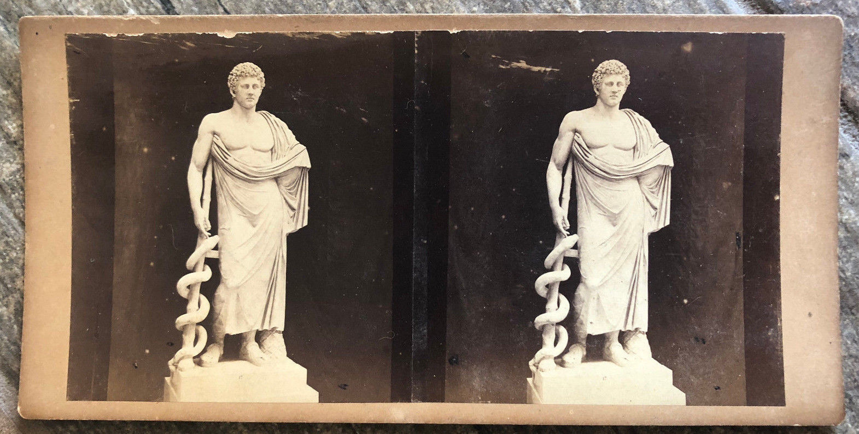

Fig. 1. Eur-Rome-Tibur Island-Asclepieion-Youthful Asclepius-Marble-c 320 BCE Lantern slide photograph of c 1860 by Libreria Spithover, 85 Piazza di Spagna, Roma, when the statue was removed from Isla Tiburina to the Braccio Nuovo hallway of the Vatican Museum.

Another Statue of the Aged Aesculapius was also erected on Isola Tiburina thus encompassing the life of this renowned physician.

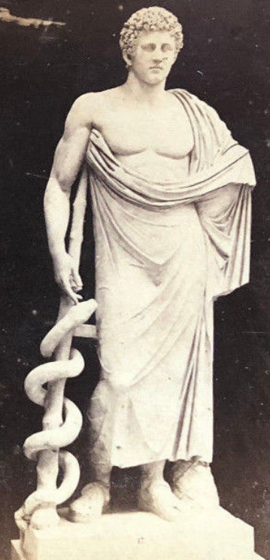 ­­­­­­ 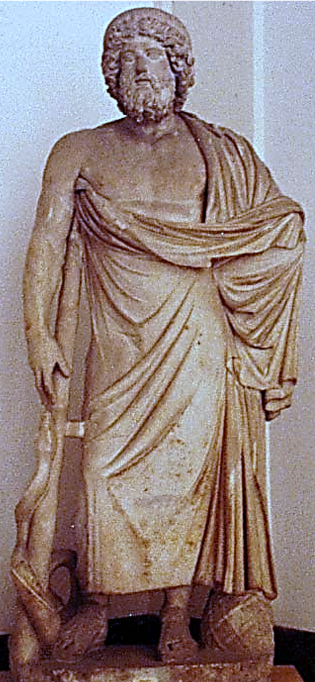

Figs. 2, 3. A comparison of the youthful and the bearded Aesculapius. The youthful sculpture was removed from the Insula Tiburina temple to the Braccio Nuovo hallway of the Vatican Museum c 1860 as depicted in the lantern slide by Libreria Spithover, 85 Piazza di Spagna. The bearded sculpture now in the Museo Archeologico Nazionale, Napoli, was also originally on the Insula Tiburina, Rome. These two sculptures encapsulate the life of this revered physician in nearly identical iconographies suggesting that the same sculptor was responsible for both: the shape and placement of the *corpus substultim* or body crutch (which the physician has removed from the patients, because the Aesculapian snakes have removed the source of infection and bodily ailments), the bodily posture with the main weight placed on the left foot, similar folds in the togas, similar foot placements and leather straps on the sandals and similar pine cone seed cross-hatching by the left foot symbolizing new life (for the patients).

**Case no.: 4**

**Accession Number:**

**Formal Label:** Eur-Rome-Tibur Island-Asclepieion-Youthful Asclepius-Marble-c 320 BCE

**Display Description:**

After the great plague of Rome in 293 BCE, the Senate commanded the Roman Elders led by Quintus Ogulnius Gallus, a member of the *collegium decemviri sacris faciundis* to consult the Sibylline Books which advised the Elders to sail on a Roman trireme to Epidauros where there was a hospital and physicians of "" (Asklepios), which had been successful in treating the populace during the 5th c BCE Peloponnesian Wars. The Roman trireme returned to Insula Tiburina (Tibur Island), chosen because of the Tiber River waters which were deemed crucial for treating patients in their various forms of incubation. A hospital (Aesclepieion) was built of ashlar marble in the form of the returning Roman trireme.

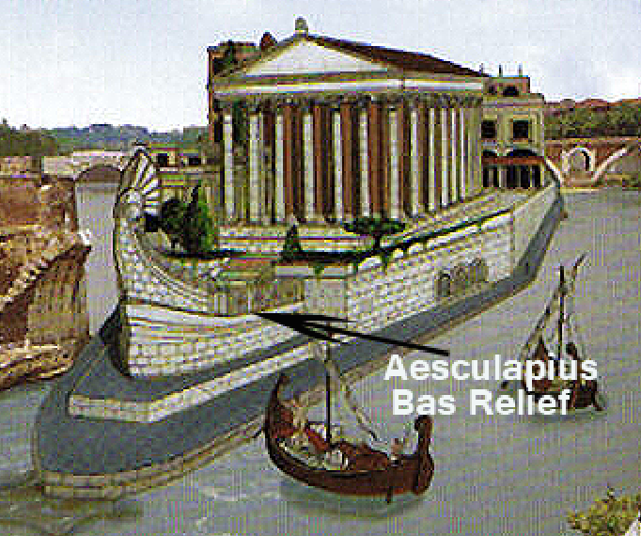

Fig. 4. An artist’s rendition of the ashlar marble model of the returning Roman trireme complex of buildings related to the major colonnaded hospital temple of Aesculapius (Latin) on Insula Tiburina, Rome. After https://opusmei.files.wordpress.com/2012/06/isola_tiberina.jpg The approximate location of an effaced Aesculapius bas-relief sculpture is marked by the arrow (see below). The perfectly rectangular ashlar masonry blocks are a prominent architectural feature.

**.**

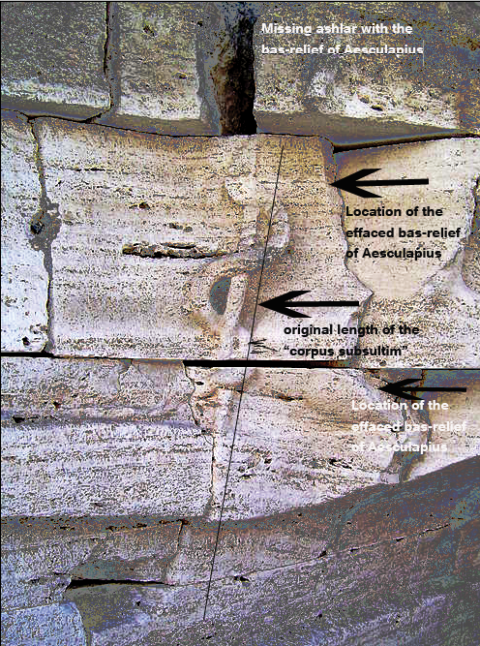

Fig. 5. Another portrayal of Aesculapius as a bas-relief sculpture which greeted new patients on Isola Tiburina. Although it has been effaced an idea of its position and size can be adduced from the four-foot-length of the bas-relief of Aesculapius’ “body crutch” or “*corpus subsultim,”* which was not a mere “rod,” “staff” or “*Virgam*” as has been popularly supposed, since a *Virgam* only signified a staff of mere generic authority. We can surmise where Aesculapius stood relative to this crutch from the badly chipped and removed ashlar masonry. The ashlar model of the ship that once carried the physicians from Epidauros to Rome’s Insula Tiburina at the behest of the Roman Elders on occasion of a devastating plague in the 3rd c BCE is evidence of the great reverence with which Aesculapius was held in the Eternal City. Photo after <https://upload.wikimedia.org/wikipedia/commons/thumb/1/19/Carving_of_the_snake>.

LC Classification: BL820.A4

**Date or Time Horizon:** 300 BCE

**Geographical Area:** Isola Tiburina

**Map:**



Aerial photo of the modern Isola Tiburina after <http://roma.andreapollett.com/S1/ROMA-C8A.JPG>. The prow area of the ashlar trieme model is to the lower right.

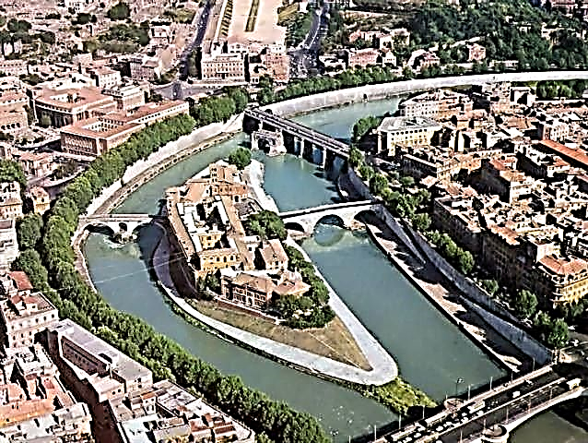

Aerial photo of the modern Insula Tiburina after <https://i.pinimg.com/originals/86/a9/3b/86a93b064f24593e315d3d775cccf91a.jpg>.

The prow area of the ashlar trireme model is to the lower right.

**GPS coordinates:** 41.890725, 12.477398

**Cultural Affiliation:** Aesculapius

**Medium:** Lantern slide by Libreria Spithover, 85 Piazza di Spagna c 1860 of 2nd c BCE by Libreria Spithover, 85 Piazza di Spagna marble statue

**Dimensions:** Lantern slide

**Weight:** Lantern slide

**Condition: original, aged**

**Provenance:** Libreria Spithover, 85 Piazza di Spagna, Rome

**Discussion:**

Although only 32 votive inscriptions are extant, all have been found in Rome, and all concern Asklepios of Epidauros establish a direct connection with Greece. However, these sources are insufficient to establish the institution of the Aesculapius sanctuary on Insula Tiburina, but it is assumed that the ceremonies and especially the incubation rituals were similar to those of Epidauros (CIL I2, 26-29, 440, 800 ; CIL, VI, 1-20, 238, 370, 546, 841, 2799, 30844 ; Dessau, 2095 ; Ann. Épig., 1941 № 69). Some dedications express gratitude for healings by revelatory dreams and the efficacy of the domesticated Aesculapian snakes that were thought to remove infectious bacteria with their flicking tongues, as patients slept during their incubations (Festus exe. 110 M (p. 98 éd. Lindsay). The Greek language was used in stories of healing that have been discovered in the Insula Tiburina temple-hospital (Inscriptiones Graecae Urbis Romae (IGUR) éd. L. Moretti, № 148. These healings were clinically managed by physicians, who were specialized in Greek Asklepian medicine, which suggests that they were of Epidauran origin or trained in Epidauran techniques.

Several Roman rulers advocated these Epidauran Greek healing methods and their political implications. Antonines were especially prominent in advocating for Aesculapius. In Pergamon, Hadrian was accepted as a  (LE GLAY, Hadrien et l'Asclépieion de Pergame, BCH 100 (1976), pp. 347-372. Antonínus the Pious recovered the story of how the Roman Trireme docked at the Insula Tiburina, when the Aesculapian snake it was harboring deborded at the island, and this was taken as the sign that this was the sacred place for building the temple-hospital in the shape of the Roman Trireme that had brought the healing snake there (Guarducci, *L'Isola*. tab. II). Antonínus the Pious may have been the one who installed a new Aesculapius statue, found in the Renaissance on Insula Tiburina (J. Beaujeau, *La religion romaine à l'apogée de l'Empire*, vol. 1. *La politique religieuse des Antonins*, Paris 1955, p. 301). Marcus Aurelius regarded Aesculapius as one of the protective gods of the Antonine dynasty in which Asklepios of Epidaurus is named dynastic conservator *Augg [ustorum]*(Ann. Épigr., 1941, no. 69).

Aesculapius in Rome appears to have been a Political Advocate for not only immigrants, foreigners and slaves, who came from Greece and the East, but also for dynastic families. For instance, Claudius considered the healing of a slave a manifestation of divine benevolence, and the healed slave was thereby granted his manumission (Suét., CL, 25 ; 2; Cassius Dio, LX, 29 ; Modestinus (D. 40.8.2.). The modest conditions of these faithful are also visible in votive inscriptions. In documents concerning Aesculapius worship in Rome often the cognomina of writers suggests a servile or immigrant origin (cf. C. Iunius Agathopus (CIL VI, 6), Mustius Olympus (CIL VI, 14).

The dissemination of the cult of Aesculapius in the southern Italian peninsula during the early Empire is restricted to 27 epigraphical references (see Ausculum (CIL IX, 660), Misenum (Atti Taranto, X(1970), p. 441), Puteoli (CIL X, 1546-7, 1571), Atina (CIL X, 330), Tegianum (CIL X, 284). Those from northern Italy are restricted to Aquilea, Bellunum and Lebactum (Gallia Cisalpina: Aquileia (CIL V, 726-731, 8206), Bellunum (CIL V, 2036), Lebactum (CIL V, 2034), Pola (CIL V, 6), emphasizing names of Greek cognomens (P. ex. "Aesclapio, Egirus s(ervus) CIL V, 72). Although there are no traces of the Aquilea sanctuary which was probably in the heart of the commercial center and hence rebuilt, but it is probable based on the Greeks who inhabited the area that it was constructed and institutionalized on Epidaurean principles.

Apart from Aesculapius in Aquilea there are other cults that indicate the Greek cults of Artemis and Apollo, In Rome the cult of Hercules Victor was established on Insula Tiburina by one L. Minicius Natalis Quadronius Verus, c 139 CE who was also the curator of the temple (IG, XIV, 11). Inscriptions to Aesculapius from Thermal Springs in Étrurian sites of

Clusium and Vicarello that are associated with Greek cognomens (Clusium (CIL XI, 2092) - Ephaestas libertus, Vicarello (CIL XI, 3294) - L. Aiatius Phoebus), and this dissemination is expanded with inscriptions to other healing figures such as Hygeia and Salus, Jupiter, Fortuna, and Hercules (CIL VI, 425, (Iupiter), 237 et 338-9 (Fortunt), 651-52 et 3715-16 (Hercules).

Not to be overlooked are the many numismatic finds that document the prevalence of Asculapius, Hygeiea and Salus found throughout the Italian peninsula that provide evidence of little known or undiscovered temple hospitals.

**References: (see above)**

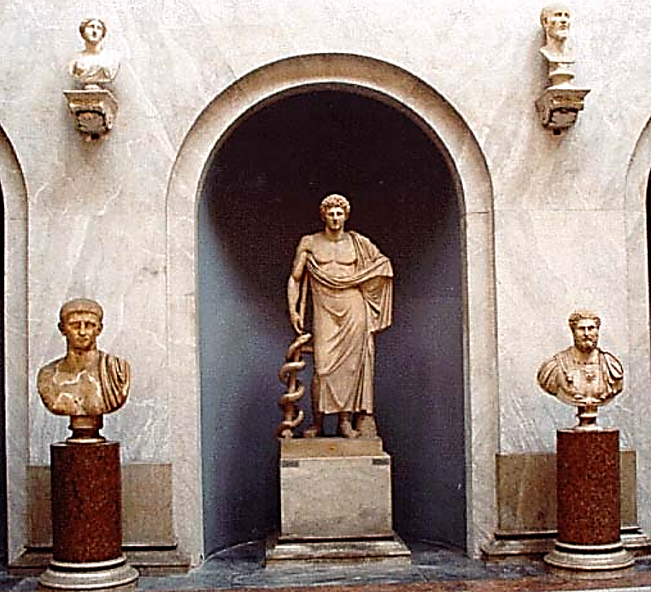

Youthful Asclepius in the architectural context of the Braccio Nuovo hallway of the Vatican Museum.

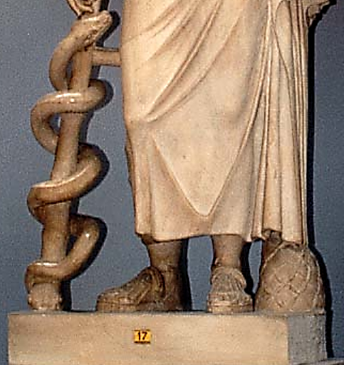

Detail of the Youthful Asclepius in the Braccio Nuovo hallway of the Vatican Museum. Note the snake, Aesculapius the sandals and pinecone at the feet. These details are similar to the statue of Asclepius from the Asclepieion on the Tibur River in Rome before the Catholic Diocese tore it down and replaced it with their own hospital. This original aged statue of Asclepius is now in Naples

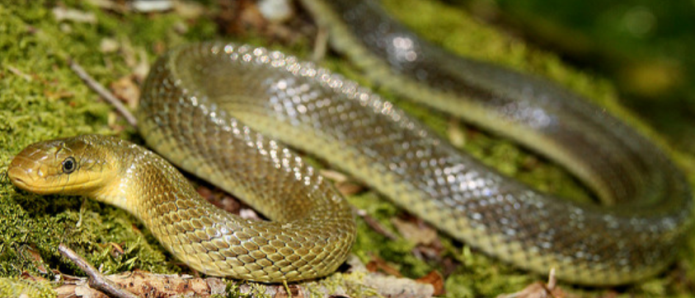

After http://canvart.club/atmose-10_14_22.html

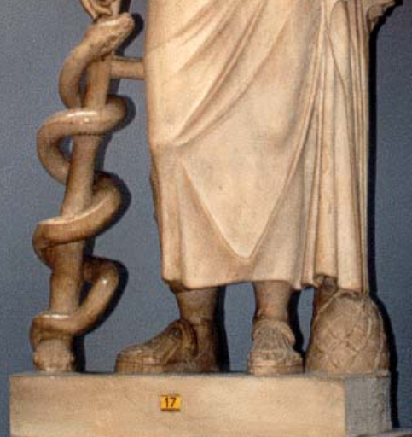

Note the snake spp. , the sandals, and the pine cone (symbol of rebirth)